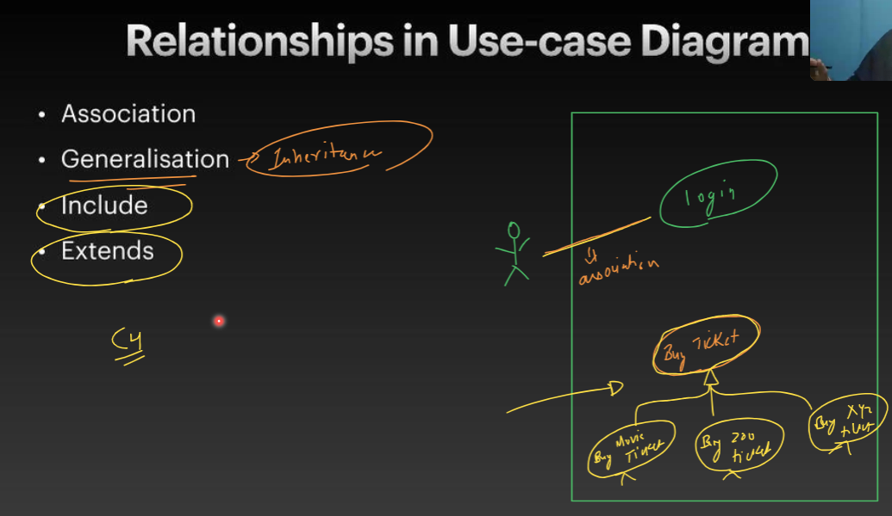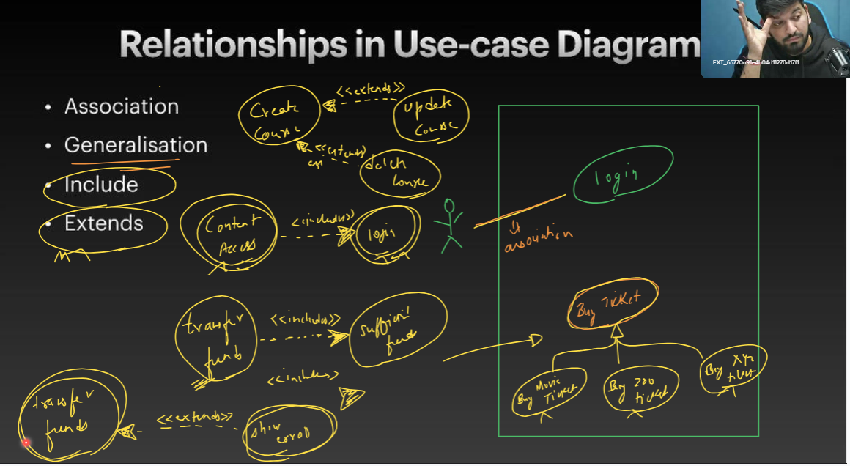

Generalisation : inheritance hota hai.

Include : jab ek case ko perform karne ke liye dusare use - case ka mandatory hona chayie,

Example- 1) money transfer karne ke liye sufficient money hona chayie.

2)content ko acces karne ke liye login hona chayie

Exclude: jab ek case ko perform karne ke liye dusare use - case ka mandatory NAHI OR hona chayie,

----

